

**COLLEGE CODE :3126**

## **COLLEGE** **NAME**: THANGAVELU ENGINEERING COLLEGE

## **DEPARTMENT**:BE. ECE

## **STUDENT** **NM**-**ID**:925ee573aab61a3a796490f81a57c908

## **ROLL** **NO**:312623106002

## **DATE**:14:05:2025

## **Completed** **the** **project** **named** **as:** AI-EBPL-healthcare diognestic and treatment

## **TECHNOLOGY**-**PROJECT** **NAME**:AI

## **SUBMITTED** **BY**,

## **NAME:**S.BARANI

## **MOBILE** **NO:**8248205980

**PHASE 4**: Performance of the project

**TITLE:** healthcare diognestic and treatment

Objective: Refine the diagnostic model for improved accuracy, optimize treatment planning, and ensure seamless integration with electronic health records (EHRs).

1. Diagnostic Model performance Enhancements

Overview: Refine the diagnostic model for better disease detection and diagnosis.

Performance Improvements:

- Accuracy Testing: Retrain the diagnostic model with a larger dataset to improve disease detection accuracy.

- Model Optimization: Apply hyperparameter tuning and pruning techniques to improve the model’s speed and efficiency.

Outcome: Improved accuracy in disease diagnosis and detection.

1. Treatment Planning Optimization

Overview: Optimize treatment planning for better patient outcomes.

Key Enhancements:

- Personalized Medicine: Develop personalized treatment plans based on patient data and medical history.

- Treatment Outcome Analysis: Analyze treatment outcomes to identify best practices and areas for improvement.

Outcome: Improved treatment effectiveness and patient outcomes.

1. Electronic Health Record (EHR) Integration

Overview: Ensure seamless integration with EHRs to improve data accuracy and reduce errors.

Key Enhancements:

- Real-Time Data Syncing: Ensure real-time syncing of patient data with EHRs.

- Improved Data Security: Implement robust security measures to protect patient data.

Outcome: Improved data accuracy and reduced errors.

1. Data Security and Privacy Performance

Overview: Ensure the security and privacy of patient data.

Key Enhancements:

- Advanced Encryption: Implement advanced encryption protocols to safeguard patient data.

- Security Testing: Conduct thorough security tests to ensure the system’s ability to handle potential threats.

Outcome: Secure and private patient data.

1. Performance Testing and Metrics Collection

Overview: Conduct comprehensive performance testing to ensure the system is ready for deployment.

Implementation:

- Load Testing: Simulate high-traffic conditions to test the system’s ability to handle large numbers of patients.

- Performance Metrics: Collect data on response times, system stability, and failure rates.

- Feedback Loop: Gather feedback from healthcare professionals to assess system usability and effectiveness.

Outcome: Optimized system performance and readiness for deployment.

Here are the key challenges in Phase 4 of the Healthcare Diagnostic and Treatment project:

**Key** **Challenges**:

1. \***Ensuring** **Diagnostic** **Accuracy**:* Refining the diagnostic model to achieve high accuracy in disease detection and diagnosis.

2. \***Optimizing** **Treatment** **Planning**:* Developing personalized treatment plans that lead to better patient outcomes.

3. \***Seamless** **EHR** **Integration**:* Ensuring real-time data syncing with electronic health records while maintaining data accuracy and security.

4. \***Data** **Security** **and** **Privacy**:* Protecting sensitive patient data with advanced encryption protocols and robust security measures.

5. \***System** **Scalability**:* Ensuring the system can handle large numbers of patients and high-traffic conditions without compromising performance.

**Additional** **Challenges**:

1. **Data** **Quality**:Ensuring the quality and accuracy of patient data used for diagnostic and treatment purposes.

2. **Interoperability**:Ensuring the system can integrate with different EHR systems and healthcare infrastructure.

3. **Regulatory** **Compliance**: Ensuring the system meets regulatory requirements and standards for healthcare data security and privacy

Here are the outcomes of Phase 4:

**Outcomes** **of** **Phase** **4:**

1. Improved Diagnostic Accuracy:Refined diagnostic model with improved disease detection accuracy.

2. Optimized Treatment Planning:Personalized treatment plans leading to better patient outcomes.

3. Seamless EHR Integration:Real-time data syncing with electronic health records, improving data accuracy and reducing errors.

4. Enhanced Data Security:Robust security measures protecting patient data, ensuring confidentiality and integrity.

5. Optimized System Performance: System ready for deployment, handling large numbers of patients and high-traffic conditions without compromising performance.

**Next** **Steps:**

1. Deployment: Deploy the system in healthcare settings.

2. Ongoing Monitoring:continuously monitor system performance and patient outcomes.

3. Future Enhancements: Refine and expand the system to address emerging healthcare needs.

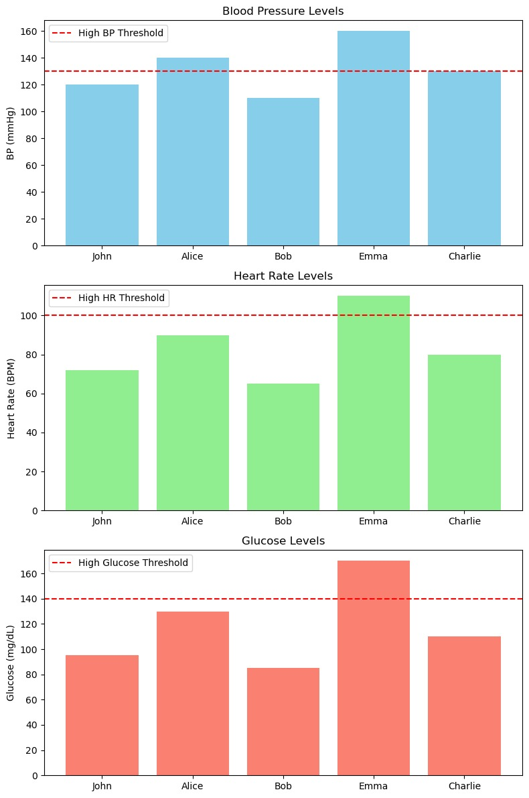

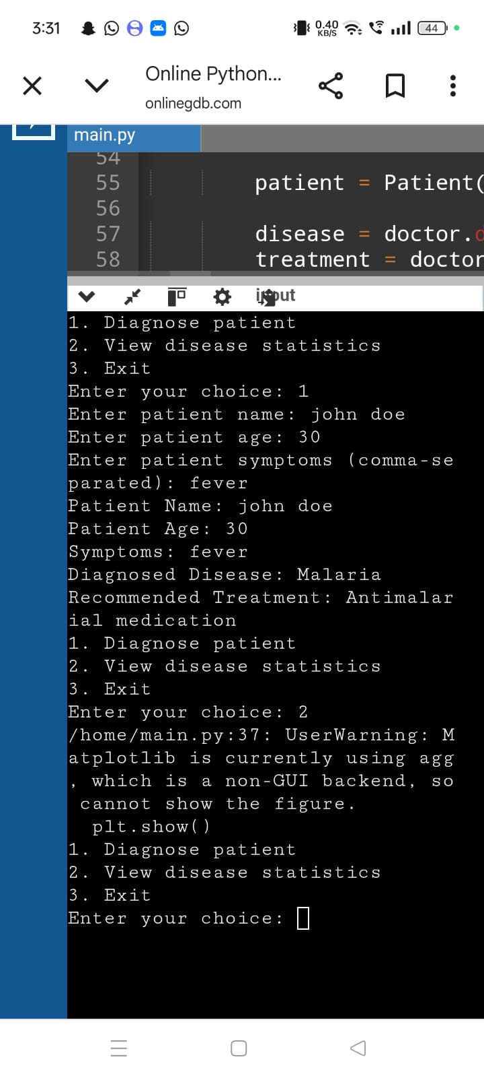**grap output is given by**